Genesis: Human Beings
September 22, 2019 Discussion Notes
Everyone is encouraged to bring a Bible (Phone apps are fine. Study Bibles are better)

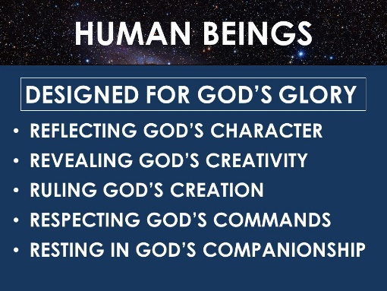
Questions:
- Think of a work of art that you love (a painting, song, poem, etc.). In what ways is it meaningful to you? Do you know anything about the artist who made the art? In what ways does the art reflect the artist?
- Do you see yourself as a work of art? What aspects of God’s character and personality are revealed through your life?
- What do you remember about each of the main points of the sermon? (seen above). What in the sermon challenged you? Do you have any questions to discuss?
- Read Psalm 8:3-9
  - What do you think David’s understanding of the universe was compared to our knowledge today?
  - What is David’s question as he considers the heavens?
  - What honor has God bestowed upon human beings? Why do you think this is?
  - What responsibility have we been given?
  - What is David’s response to all this?
- Read Acts 17:26-29
  - What parts of the earth did God want humans to inhabit?
  - What did God determine for us?
  - What should people’s response be to having been given life and a place to live?
  - How does our being made in God’s image rule out idolatry?
  - How does idolatry reverse the meaning and message of creation?
  - Do we struggle with idolatry today? (see Colossians 3:5)
- Read Genesis 1:3, Psalm 33:6, and Hebrews 11:3
  - What did God use to create the universe?
  - Now read 2 Corinthians 5:17. What does it mean that we are a “new creation”? What was the old creation?
  - How does God make people into a new creation? (See James 1:18). How is this similar to the first creation?
  - Read Romans 10:13-15. How does God get his powerful word to people? What are some ways we can be involved in this mission?
- What are some typical ways that Christians struggle to be a good reflection of the image of God? What are some ways that you personally need to be a better reflection of God’s image?
- Pray for each other’s needs. Pray that we would all glorify God as we reflect his image and live out his purposes.

