Genesis: The Fall
October 6, 2019 Discussion Notes
Everyone is encouraged to bring a Bible (Phone apps are fine. Study Bibles are better)

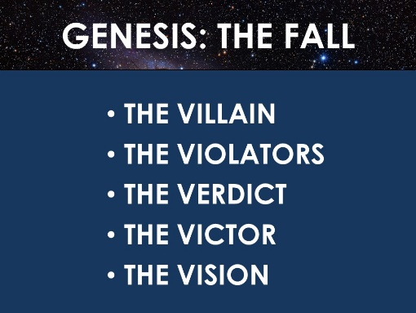
Questions:
- Think of a favorite fictional book or movie and share it with the group.
- Now think about the structure of the storyline of the book or movie you thought of. Are the similarities to the story of the Bible? Is there a villain? A crisis? What about a hero? How is the crisis resolved? Discuss together.
- What do you remember about each of the main points of the sermon? (seen above). What in the sermon challenged you? Do you have any questions to discuss?
- According to the following passages, what things does the devil do? (Matthew 4:3, John 8:44, 1 John 3:8, Luke 22:31, Zechariah 3:1, Revelation 12:9 and 1 Peter 5:8)
- How should we respond to the devil? (see James 4:7, Matthew 4:8-11, Ephesians 4:26-27, 1 Peter 5:8-9, Revelation 12:10-11, 2 Corinthians 2:10-11, and Ephesians 6:11)
- What should we do when someone we know is being tempted or tested by the devil? (see Jesus’ example in Luke 22:31-32).
- How should we pray concerning the devil’s attacks on our own lives? (see Matthew 6:9-13).
- Read Luke 10:1-3
  - What does Jesus mean by “the harvest”?
  - What is the problem regarding the harvest?
  - What two things does Jesus tell his disciples to do about this problem?
  - In v. 3, how does Jesus describe the disciples he is sending out? Does this make you nervous?
  - Now read Luke 10:17-20 (describing the conclusion of the mission trip). To what degree do God’s people need to worry about Satan? (balance this passage with some of the earlier ones)
  - What instructions did Jesus give regarding what to focus our attention on?
- Share with the group any ways in which you feel the enemy has been having too much victory (in your life or in the life of someone you care about).
- Pray together in the mighty name of Jesus. Pray for victory over the enemy’s temptations and deceptions.

