Genesis: In the Beginning, God
September 8, 2019 Discussion Notes
Everyone is encouraged to bring a Bible (Phone apps are fine. Study Bibles are better)

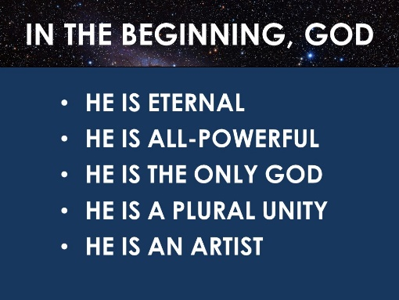
Questions:
- Think about a time when you were especially awestruck by the beauty of nature. Where were you? Share with your group.
- What do you remember about each of the main points of the sermon? (seen above). What in the sermon challenged you? Do you have any questions to discuss?
- Read Psalm 19:1-3
  - In what ways do the heavens declare God’s glory?
  - What knowledge do they display?
- In the creation stories of other ancient cultures, the gods created the world out of preexisting material. Most Christian theologians believe that the true God created the world ex nihilo (Latin for “out of nothing). Read the following passages: Hebrews 11:3, Revelation 4:11, John 1:3, and Romans 4:17 (check more than one translation for this verse). Based on these passages, do you agree with these theologians?
- Based on the following Scriptures, what was God the Father’s role in creation? (Deuteronomy 32:6, Malachi 2:10, Isaiah 64:8, and 1 Corinthians 8:6)
- Based on the following Scriptures, what was God the Son’s role in creation? (Hebrews 1:2, Colossians 1:15-17, John 1:1-3. Also reread 1 Corinthians 8:6)
- Based on the following Scriptures, what was God the Holy Spirit’s role in creation?
  - Genesis 1:2 (compare to Deuteronomy 32:11 where “hovering” is from the same Hebrew word in both verses. Also compare to Luke 1:35)
  - Job 33:4, Psalm 33:6, and Genesis 2:7 (note that the Hebrew word for “Spirit” is the same word that is often translated “breath”)
- How would you summarize the roles of the Father, Son, and Spirit in creation?
- Read Acts 17:22-31. Paul here is preaching the gospel to Epicurean and Stoic philosophers in Athens.
  - What are the main points of Paul’s message?
  - How does Paul anchor his points in the creation story?
  - How might you use creation to share your faith with others?
  - Are you willing to share what you’ve learned about creation with someone in the next week?
- Pray for each other’s needs. Pray for a continual attitude of awe and humility toward God the Creator. Pray for courage and power to joyfully share about Him with others.

