Genesis: Creation and Science
September 15, 2019 Discussion Notes
Everyone is encouraged to bring a Bible (Phone apps are fine. Study Bibles are better)

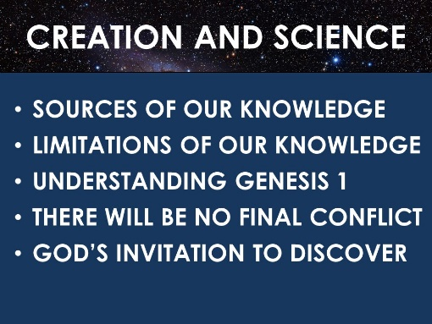
Questions:
- Has your faith in God ever been shaken because of scientific argument? Tell the story. How did faith win out in the end?
- What do you remember about each of the main points of the sermon? (seen above). What in the sermon challenged you? Do you have any questions to discuss?
- Read Psalm 19:1-14 (some of this is review from last week)
  - What are the two major sources of revelation described in this psalm?
  - What do they each teach us?
  - When people think of instructions, decrees, and commandments, they often think of rules that keep them from having fun. But what is David’s description of God’s law?
  - Look at the description of the sun in vv. 5-6. Some would say that the Bible is wrong here because we now know that the sun does not circle the earth. What are your thoughts about this challenge? (Note: if you need help with this, your life group leader will have some ideas).
  - In what ways are you listening to what both nature and Scripture have to say to you? In what ways can you be more attentive?
- Read 1 Kings 4:30-34
  - What evidences are given for Solomon’s intelligence?
  - What branches of science was Solomon teaching?
  - Now read 1 Kings 11:4-8. In the end, how helpful was Solomon’s scientific knowledge to his spiritual life?
  - In what ways can scientific knowledge be helpful to our faith? In what ways is it limited?
- Read James 2:17-19
  - Demons believe in God’s existence and they understand certain attributes of God. What are they missing?
  - What is the difference between belief (as used in this passage) and faith?
  - How can we move from belief in facts about God to a relationship-based faith in God?
- Read Romans 14:1-5, Romans 14:19, and Romans 14:22. This passage has to do with disagreements among Jewish Christians about Jewish laws. But the principle taught has many broader applications.
  - How would you summarize Paul’s teaching in this passage?
  - What are some “disputable matters” amongst Christians when it comes to science?
  - How would you apply the principles taught in Romans 14 to scientific disagreements?
- Pray for each other’s needs. Pray for a deep and lasting faith that is not easily shaken. Pray that Christians would be humble and charitable regarding issues on which they disagree.

