Genesis: God’s Design for Marriage
September 29, 2019 Discussion Notes
Everyone is encouraged to bring a Bible (Phone apps are fine. Study Bibles are better)

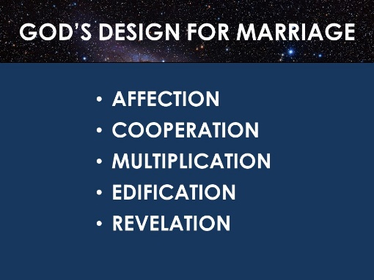
Questions:
- If you are married (or have been married), how did you first meet your spouse and what were some qualities that you found attractive? If you have never been married (but would like to be), what type of person could you see yourself marrying? Share with your group.
- What do you remember about each of the main points of the sermon? (seen above). What in the sermon challenged you? Do you have any questions to discuss?
- Read Matthew 19:3-6
  - To answer the Pharisees’ question, what does Jesus cite?
  - How many genders does Jesus recognize in this passage?
  - Based on the description of Jesus’ ministry in the Gospels, how do you think Jesus would minister to someone today who claims that they don’t identify as male or female?
  - According to Jesus, when a man and woman are married, who joins them together?
  - What was Jesus’ answer to the Pharisees about divorce?
  - Read Matthew 19:9, 1 Corinthians 7:15, and 1 Corinthians 7:39. According to these Scriptures, what are three legitimate reasons for a marriage ending?
  - What are some keys that would help more Christian couples have strong, healthy marriages that stand the test of time? Discuss together.
- Read 1 Timothy 1:2 and Titus 1:4.
  - As far as we know, the Apostle Paul was not married and never had any biological children. But in what ways was he a father?
  - How can this encourage Christians today who never marry or have kids of their own?
- Takes some time to individually read Proverbs 31:10-31. Then discuss as a group.
  - What qualities of the “Proverbs 31 Woman” stand out to you? What kind of wife is she? How does she care for her household?
  - According to verse 10, how many women can likely live up to this standard?
  - In what ways do you think this passage can be helpful to women without being overwhelming or burdensome?
- Takes some time to individually read Job 31:1-40 (this is Job’s description of how he has lived his life as a godly man). Then discuss as a group.
  - What qualities of the “Job 31 Man” stand out to you? What kind of husband is he? How does he care for his household?
  - In what ways do you think this passage can be helpful to men without being overwhelming or burdensome?
- Pray for each other’s needs. Pray that God would bless marriages in your group, in our church, and in the wider society. Pray for any who are single but would like to be married. Pray that Christian families would be a good example to the world.

